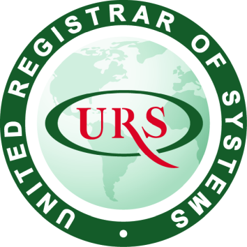
Certificate of Registration
This certificate has been awarded to
ANT CUSTOM LASER CUTTING FABRICATION INC.

3 Alfred Kuehne Blvd. Unit # 2, Brampton, ON, L6T 4K3, Canada
in recognition of the organization's Quality Management System which complies with
ISO 9001:2015
The scope of activities covered by this certificate is defined below
Manufacturing of Custom Parts & Products using Laser Cutting and Fabrication Processes for Commercial and Industrial Sectors

Certificate Number: |  |  | Date of Issue: (Original) |  |  | Date of Issue:
205590/A/0001/UK/En |  |  | 14 September 2020 |  |  | 14 September 2020
Issue No: |  |  | Expiry Date:
1 |  |  | 13 September 2023
Issued by: |  |  |  |  | On behalf of the Schemes Manager
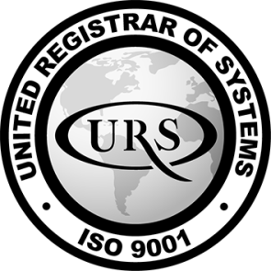 |  | 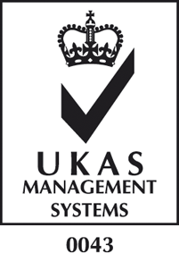 |  | 